Synthesis of substituted spiro thiadiazoles via reaction between cycloalkylidenehydrazinecarbothioamides and 2,3-diphenyl-cycloprop-2-enone
Alaa A. Hassan¹, Ashraf A. Aly*¹, Nasr K. Mohamed¹, Olaf Fuhr², Ahmed T. Abdel-Aziz ¹, Lamiaa E. Abd El-Haleem

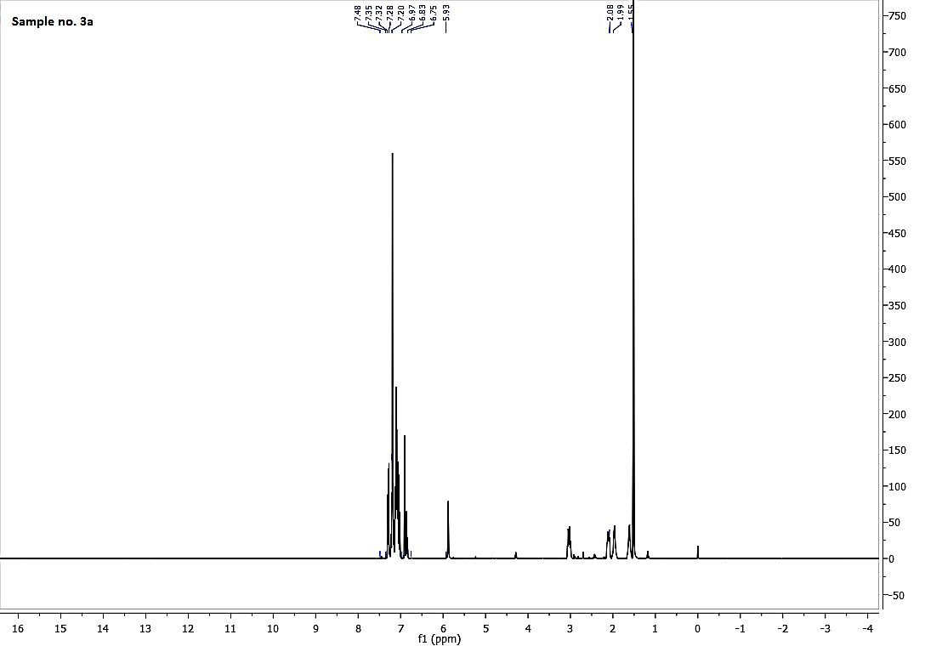
SI Figure 1. ¹H NMR spectrum of 3a
¹H NMR (400 MHz, CDCl₃): δ = 1.52-1.55 (m, 4H, cyclic CH₂), 1.98-2.09 (m, 4H, cyclic-CH₂), 5.93 (s, 1H, benzylic-CH), 6.90-6.93 (m, 2H, Ar-H), 7.00-7.48 (m, 10H, Ar-H and NH₂)
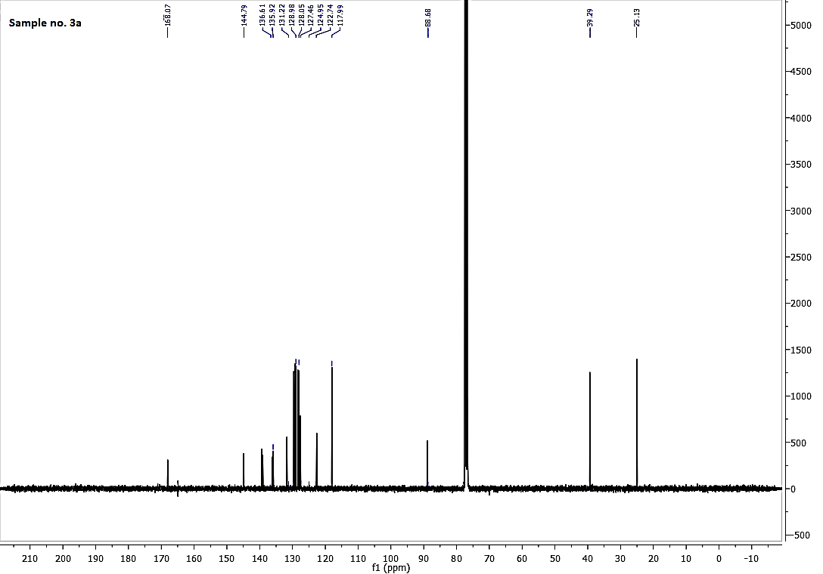
SI Figure 2. ¹³C NMR spectrum of 3a
SI Figure 3. IR spectrum of 3a
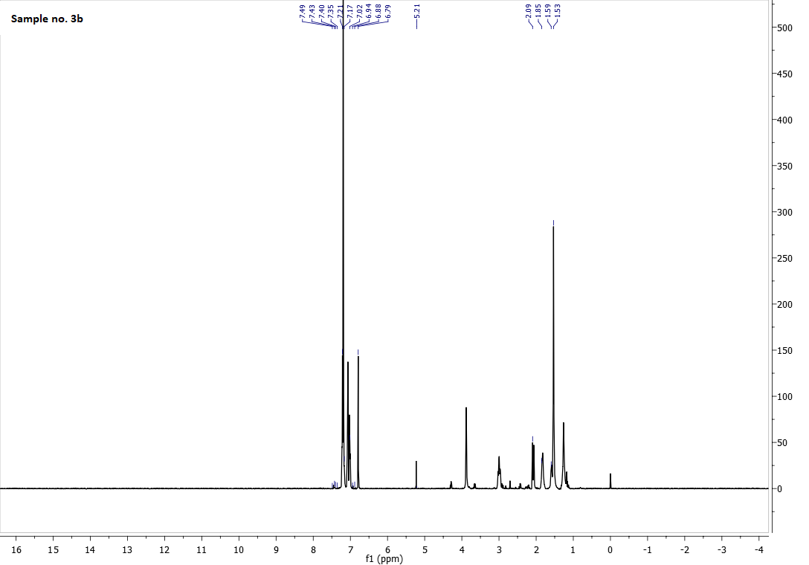
SI Figure 4. ¹H NMR spectrum of 3b
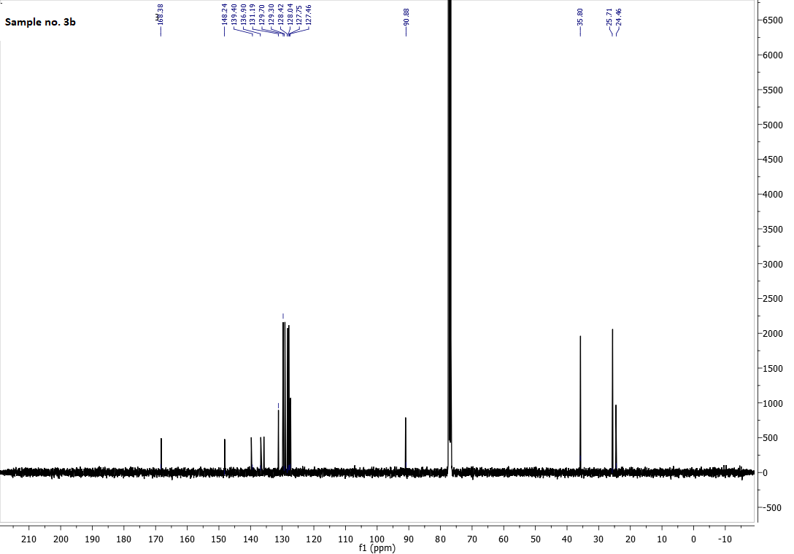
SI Figure 5. ¹³C NMR spectrum of 3b
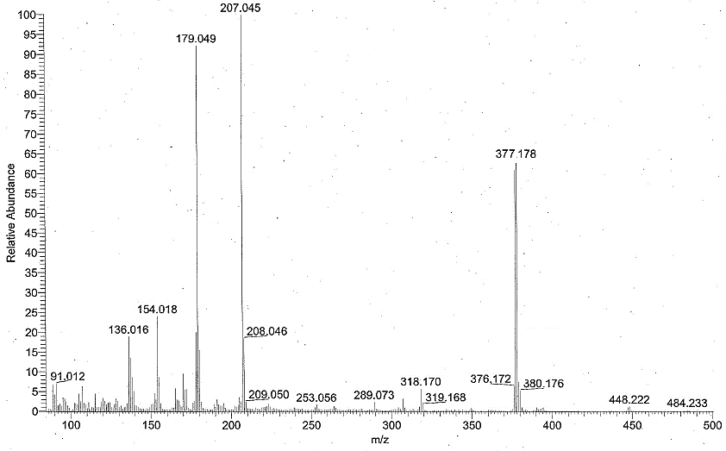
SI Figure 6. Mass spectroscopy of 3b
SI Figure 7. IR spectroscopy of 3b

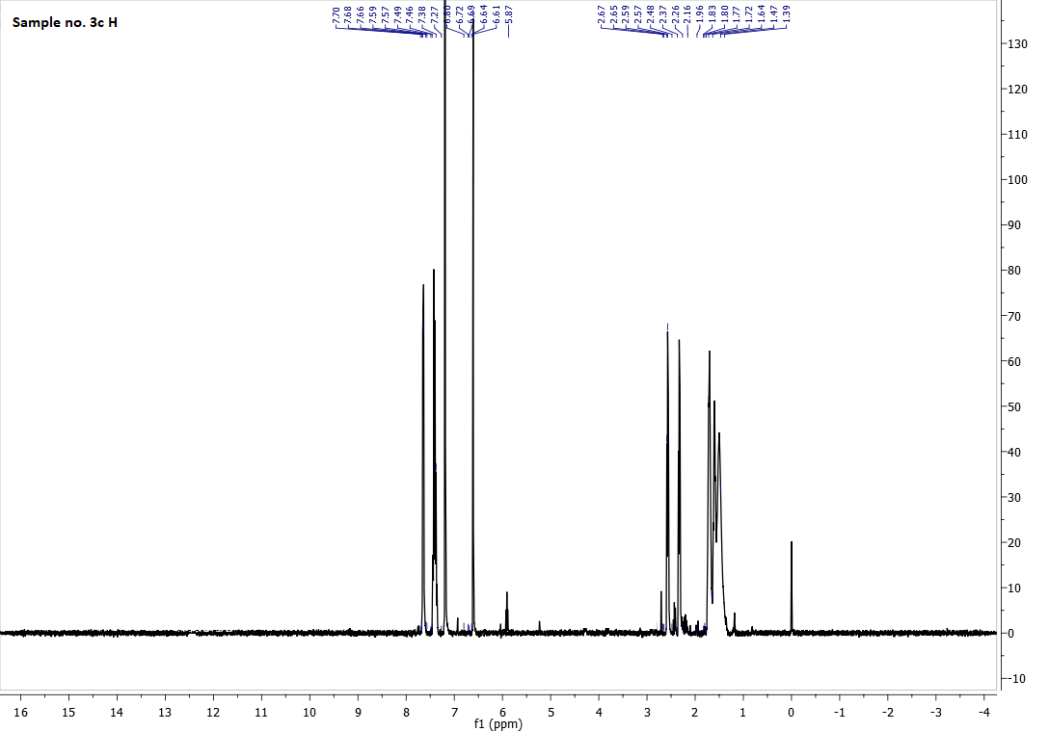
SI Figure 8. ¹H NMR spectroscopy of 3c
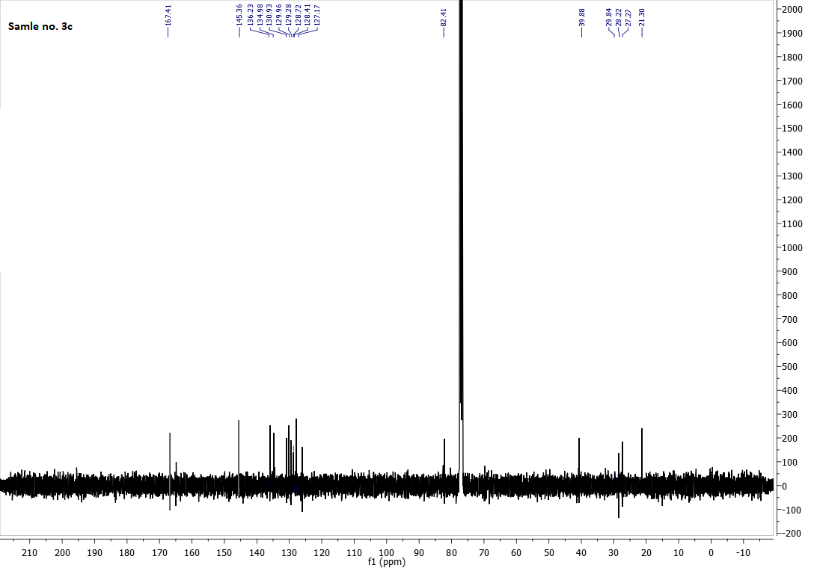
SI Figure 9. ¹³C NMR spectroscopy of 3c

SI Figure 10. IR spectroscopy of 3c
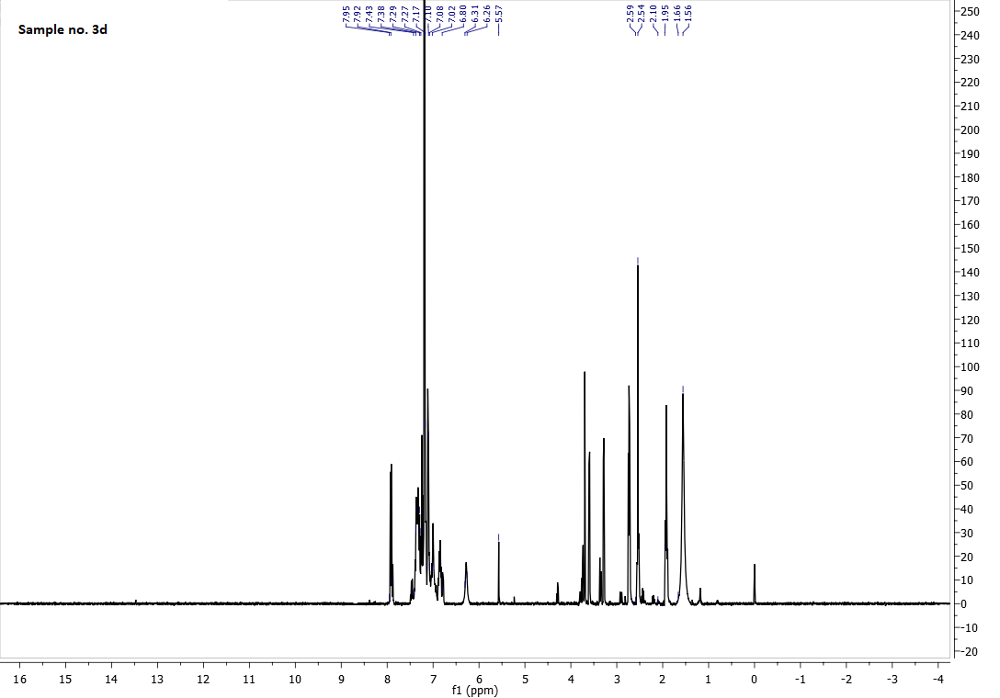
SI Figure 11. ¹H NMR spectroscopy of 3d
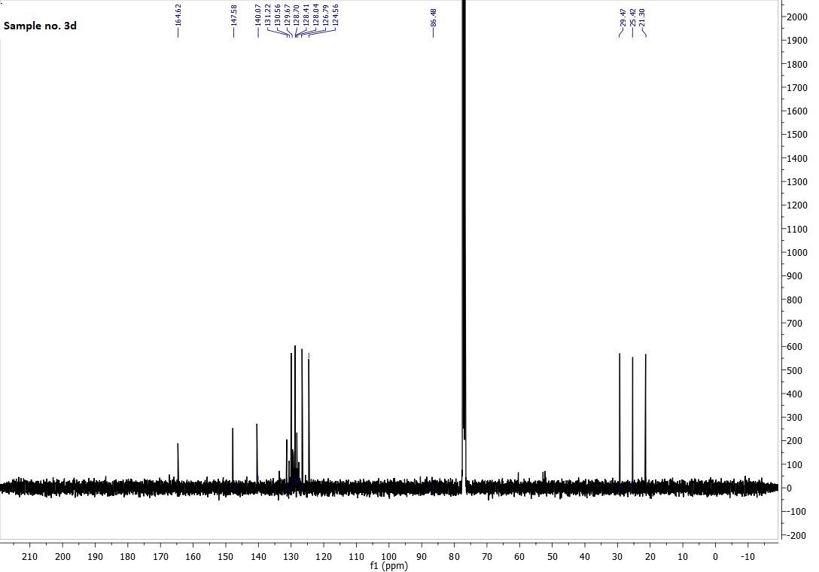
SI Figure 12. ¹³C NMR spectrum of 3d
SI Figure 13. IR spectroscopy of 3d
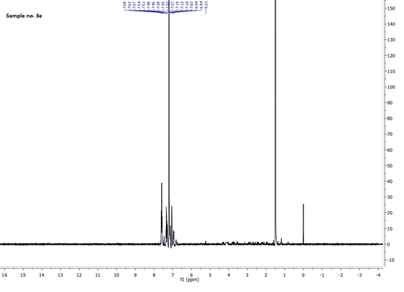
SI Figure 14. ¹H NMR spectrum of 3e
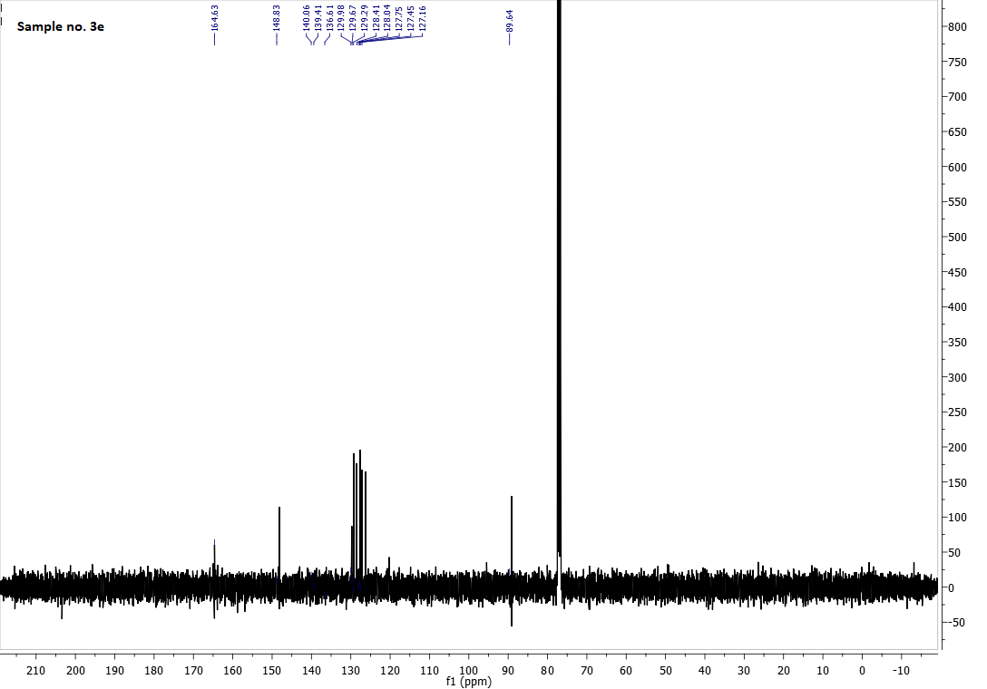
SI Figure 15. ¹³C NMR spectrum of 3e
SI Figure 16. Mass spectroscopy of 3e
SI Figure 17. IR spectrum of 3e
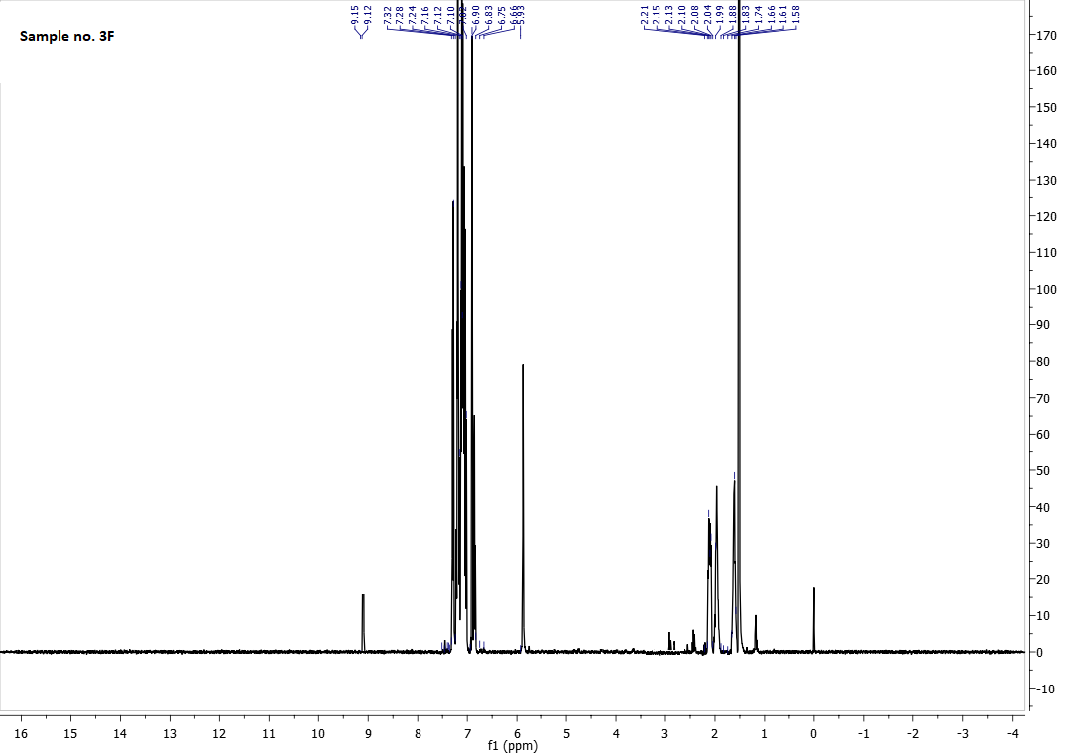
SI Figure 18. ¹H NMR spectrum of 3f
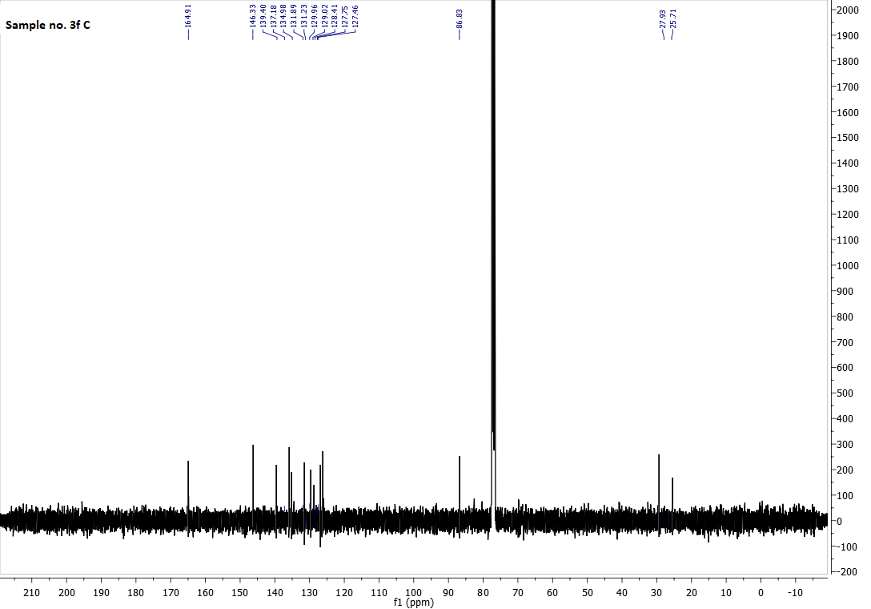
SI Figure 19. ¹³C NMR spectrum of 3f
SI Figure 20. Mass spectroscopy of 3f
SI Figure 21. IR spectrum of 3f

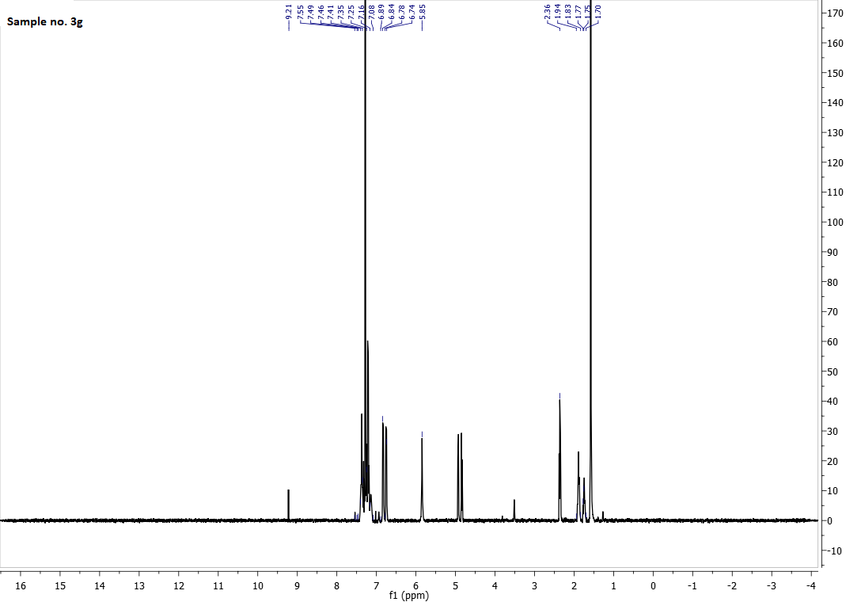
SI Figure 22. ¹H NMR spectrum of 3g
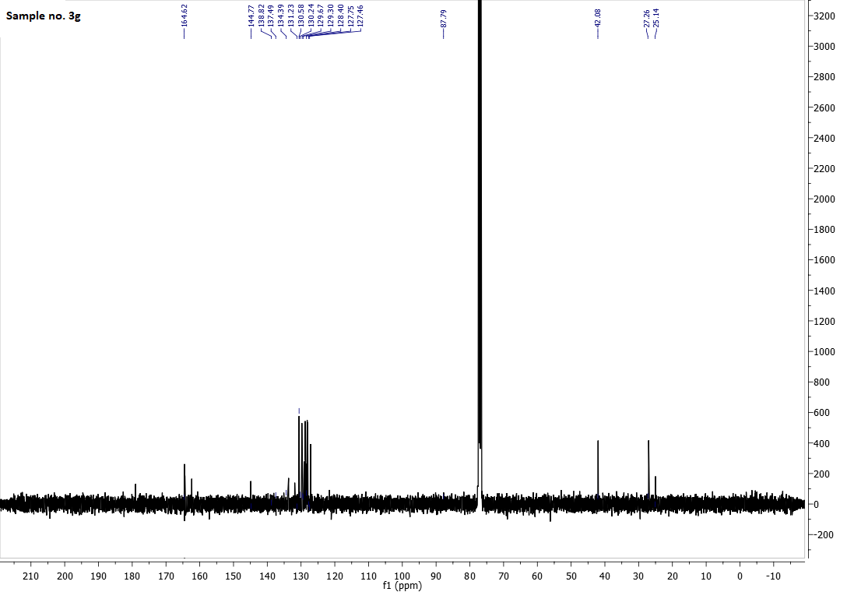
SI Figure 23. ¹³C NMR spectrum of 3g
SI Figure 24. Mass spectroscopy of 3g
SI Figure 25. IR spectrum of 3g
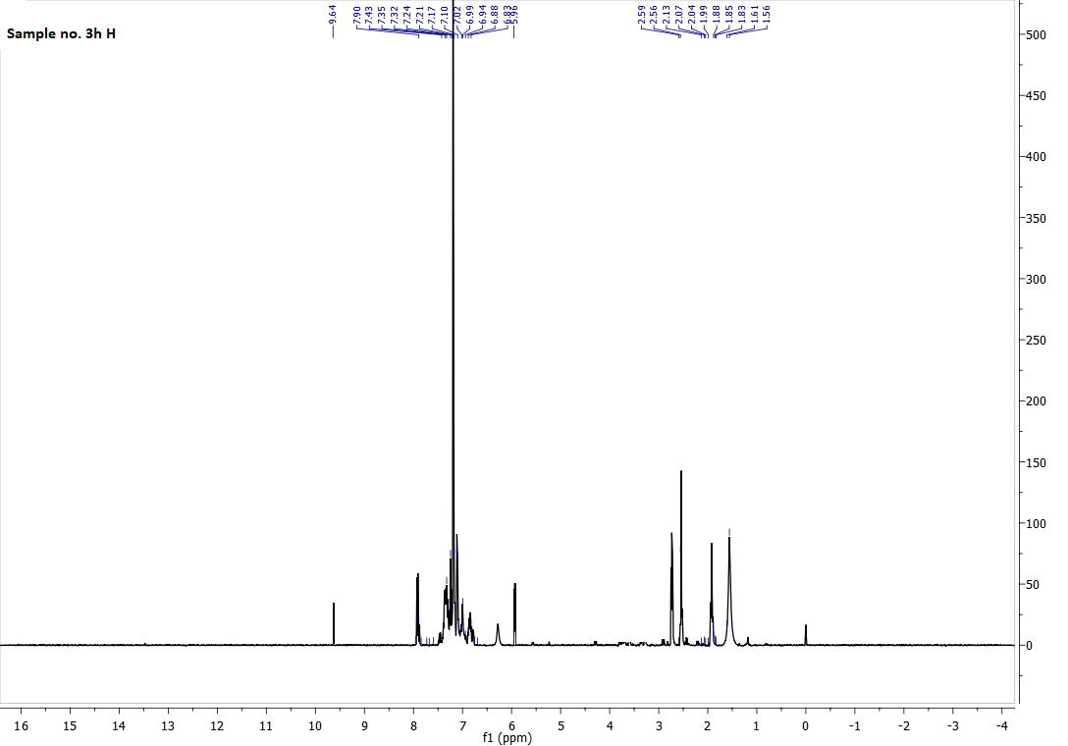
SI Figure 26. ¹H NMR spectrum of 3h
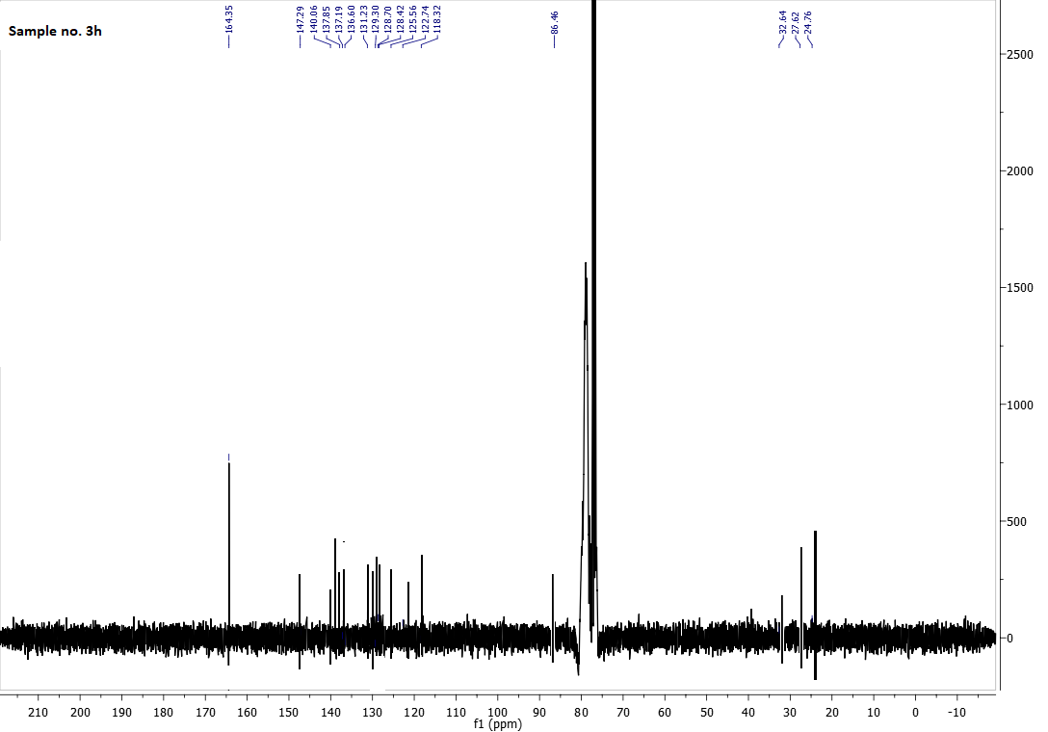
SI Figure 27. ¹³C NMR spectrum of 3h
SI Figure 28. Mass spectroscopy of 3h
SI Figure 29. IR spectrum of 3h
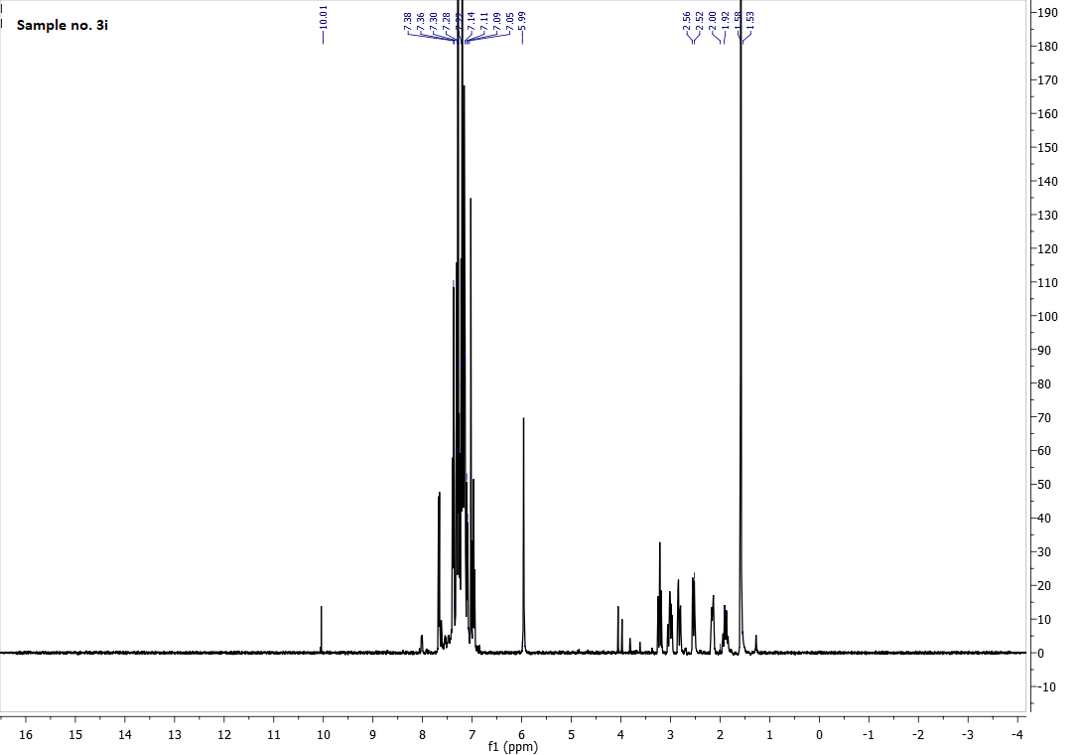
SI Figure 30. ¹H NMR spectrum of 3i
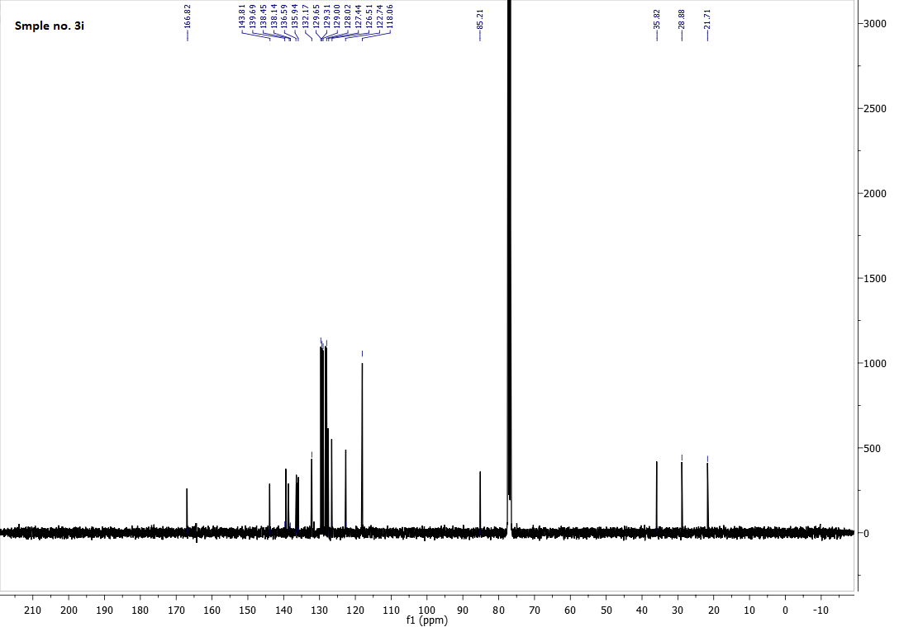SI Figure 31. ¹³C NMR spectrum of 3i
SI Figure 32. Mass spectroscopy of 3i
SI Figure 33. IR spectrum of 3i

Crystallography

Crystallographic data for compounds 3e and 3f reported in this paper have been deposited with the Cambridge Crystallographic Data Centre as supplementary information no. CCDC-2306175 and 2306176. Copies of the data can be obtained free of charge from https://www.ccdc.cam.ac.uk/structures/.

Experimental Details.
Single crystal X-ray diffraction data were collected on a STOE STADI VARI diffractometer equipped with a Dectris Eiger 4M detector with monochromated Ga Kα (1.34143 Å) radiation generated by a Excilium MetalJet at low temperature. Using Olex2 [1], the structures were solved with the ShelXT [2] structure solution program using Intrinsic Phasing and refined with the ShelXL [3] refinement package using Least Squares minimization. Refinement was performed with anisotropic temperature factors for all non-hydrogen atoms; hydrogen atoms were refined freely. Crystallographic data and refinement details are summarized in Table S1.

Table S1. Crystallographic data and refinement details of 3e and 3f.
Compound | 3e | 3f
Empirical formula | C₂₉H₂₁N₃OS | C₂₇H₂₅N₃OS
Formula weight | 459.55 | 439.56
Temperature/K | 180 | 180
Crystal system | triclinic | monoclinic
Space group | P1̅ | P2₁
a/Å | 11.5292(2) | 6.2251(2)
b/Å | 14.1199(2) | 16.0623(7)
c/Å | 14.8247(2) | 11.1673(5)
α/° | 78.4960(10) | 90
β/° | 89.9950(10) | 94.979(3)
γ/° | 77.0420(10) | 90
Volume/Å³ | 2302.11(6) | 1112.40(8)
Z | 4 | 2
ρ_{calc}g/cm³ | 1.326 | 1.312
μ/mm⁻¹ | 0.948 | 0.961
F(000) | 960.0 | 464.0
Crystal size/mm³ | 0.24 × 0.23 × 0.2 | 0.22 × 0.2 × 0.18
Radiation | GaKα (λ = 1.34143) | GaKα (λ = 1.34143)
2Θ range for data collection/° | 5.298 to 125 | 6.912 to 125.028
Index ranges | -15 ≤ h ≤ 15, -18 ≤ k ≤ 17, -19 ≤ l ≤ 6 | -8 ≤ h ≤ 7, -12 ≤ k ≤ 21, -14 ≤ l ≤ 13
Reflections collected | 39490 | 23543
Independent reflections | 10888 [R_{int} = 0.0135, R_{sigma} = 0.0117] | 4234 [R_{int} = 0.0127, R_{sigma} = 0.0071]
Indp. refl. with I≥2σ (I) | 9571 | 4167
Data/restraints/parameters | 10888/0/781 | 4234/1/389
Goodness-of-fit on F² | 1.061 | 1.030
Final R indexes [I≥2σ (I)] | R₁ = 0.0308, wR₂ = 0.0837 | R₁ = 0.0234, wR₂ = 0.0624
Final R indexes [all data] | R₁ = 0.0350, wR₂ = 0.0854 | R₁ = 0.0237, wR₂ = 0.0625
Largest diff. peak/hole / e Å⁻³ | 0.31/-0.32 | 0.18/-0.15
Flack parameter | - | -0.010(8)
CCDC number | 2306175 | 2306176

[1] O.V. Dolomanov, L.J. Bourhis, R.J. Gildea, J.A.K. Howard, H. Puschmann, J. Appl. Cryst. 2009, 42, 339–341.
[2] G.M. Sheldrick, Acta Cryst. A 2015, A71, 3–8.
[3] G.M. Sheldrick, Acta Cryst. C 2015, C71, 3–8.

